

**SoW to Mahindra Financial Services Limited for**

**Landing Zone Setup**

Point of Contact : Bhavik Vyas

Contact Number : +918447627688

Document Name : Blazeclan_MahindraFinance_Landing Zone

Client : Mahindra Financial Services Limited

Date : 19 January 2023

Contents

1 Executive Summary 4

2 Business Requirements 5

3 Solution To Business Requirements 6

3.1 Solution Overview 6

3.2 Solution Approach 6

4 Scope Of Work 12

4.1 Pre-Requisites 12

4.2 Activities In-Scope 12

4.3 Out Of Scope 13

5 Indicative Plan 14

5.1 Indicative Timelines 14

6 Risks, Assumptions & Dependencies 15

6.1 Risks 15

6.2 Assumptions 15

6.3 Dependency 15

7 Commercials 16

7.1 Professional Services Cost 16

7.2 Payment Milestone 16

8 Terms and Conditions 17

9 Contract & Agreement 18

10 Appendix 19

10.1 About Blazeclan 19

# Executive Summary

Blazeclan is pleased to submit this response to **Mahindra Financial Services Limited** (hereby referred as Mahindra Finance) for implementation of the Landing zone on AWS cloud.

Mahindra & Mahindra Financial Services Limited (Mahindra Finance), part of the Mahindra Group, is one of India’s leading non-banking finance companies. Focused on the rural and semi-urban sector, the Company has over 8.4 million customers and has an AUM of over USD 11 Billion. The company is a leading vehicle and tractor financier and also offers other products like Fixed Deposits and SME Loans. The company has over 1,384 offices and reaches out to customers spread over 3,80,000 villages and 7,000 towns across the country.

Mahindra Finance are looking for partner who can support them with implementation of Landing Zone on AWS Cloud using Control Tower.

Blazeclan, an AWS Premier Consulting Partner, being an expert in AWS Cloud infrastructure setup, understands Mahindra Finance objectives and, with our experience with such requirements, Blazeclan proposes solution on AWS Landing Zone, with a variety of matured native services, to ensure convenience and use of the state-of-the art technology for the solution on a scalable, flexible, and cost-effective cloud platform.

Blazeclan team will closely work with **Mahindra Finance** to work towards jointly defining the results and the means to achieve them. How we work together is as important as what we achieve is together. Blazeclan is eager to address your project goals and our collaborative style is one way we achieve this.

# Business Requirements

Mahindra Finance is looking for a partner who can assist them in setting up new AWS Landing zone using control tower. The objective for creating a Landing Zone is to host the respective workloads within the new independent Landing Zone. This setup will help them to host applications and streamline their workloads in new AWS setup with better security and operational efficiency.

As per our understanding of the requirements shared over email and subsequent calls, the major focus of the customer will be performing the following set of activities along with setting up infrastructure on the AWS cloud:

* Setting up of the new AWS Landing zone using Control Tower
* LZ compliance guidelines should be adhered as per regulatory compliance

# Solution To Business Requirements

## Solution Overview

As part of the solutions proposed by Blazeclan we will be performing the below set of activities to cater the business requirements of Mahindra Finance which will fulfil their requirement of setting up a new landing zone for their application workloads on AWS.

1. Requirement Gathering
2. Landing Zone Design
3. Landing Zone Setup using AWS Control Tower
4. AWS Account setup

## Solution Approach

### Requirement Gathering

Requirement gathering phase involves workshops with multiple stakeholders to understand the applications, network requirements, security requirements, automation, current processes, and tools.

The requirement gathering phase will act as the foundation for the overall project. There will be involvement of stakeholders/SMEs from the Mahindra Finance and Blazeclan side to understand the current architecture, configuration and dependencies and these will be discussed to create the target AWS architecture for landing zone setup. Blazeclan will review the existing workloads and application sets and engage with the Customer SMEs to assess the existing cloud landscape and define the steps to follow for setting up their applications set on the AWS cloud environment.

### AWS Control Tower Architecture

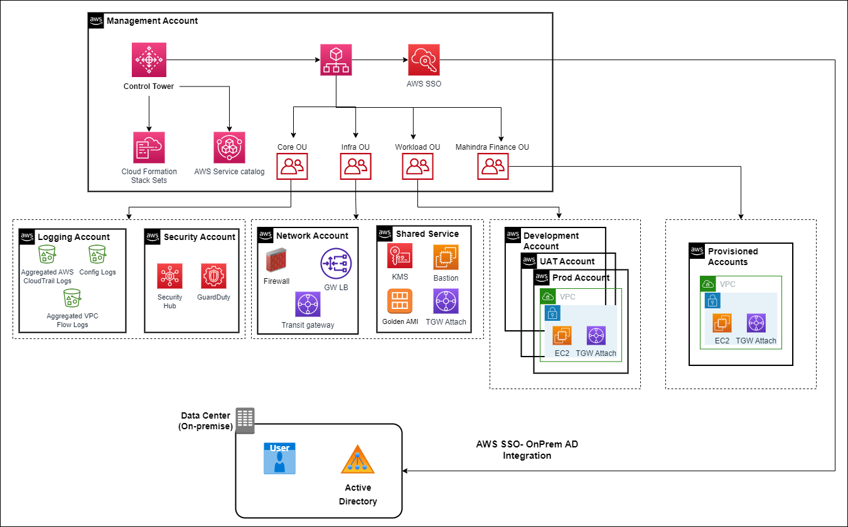

The purpose of setting up an AWS Landing Zone with AWS Control Tower is to use the Well Architected principles to achieve the following objectives:

* To provide a strategy and set of high-level recommendations to be used by an Account Bootstrapping Pipeline to apply standard configuration to all AWS accounts, which will bring them to a secure and compliant baseline
* To ensure that all actions taken within an account are logged and stored in a secure location in a dedicated AWS account
* To ensure that point-in-time configurations of all resources in an AWS account are taken and stored in a secure location
* To ensure that the master account has full visibility into the sub accounts in terms of billing as well as the services being used
* To ensure that the master account has the capability to create service control policies to govern and manage the AWS accounts being used by different entities in the company.

AWS Control Tower has the following fetures:

#### Landing Zone

A landing zone is a well-architected, multi-account environment that's based on security and compliance best practices. It is the enterprise-wide container that holds all of your organizational units (OUs), accounts, users, and other resources that you want to be subject to compliance regulation. A landing zone can scale to fit the needs of an enterprise of any size.

Key Areas for Designing an AWS Custom Landing Zone

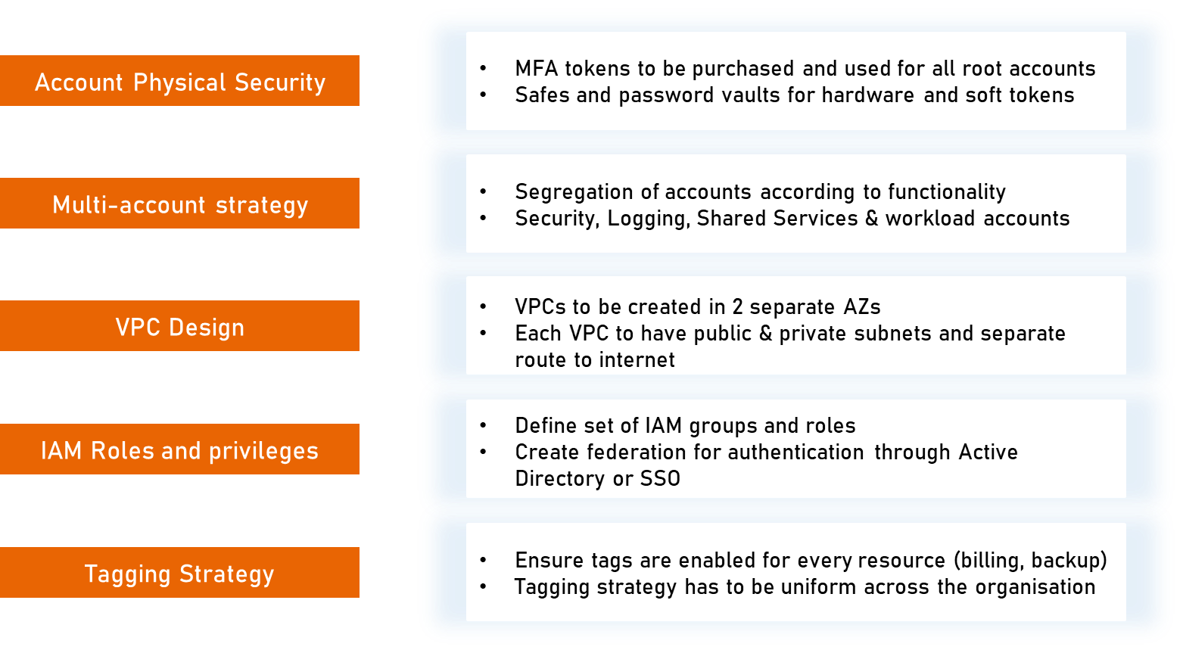

**AWS Organization Account**

This AWS account will also act as a master or root account to which all other Country entity AWS accounts will be integrated. The AWS Organizations account will provide an ability to manage the accounts in terms of security as well provide the group an overview of the billing being incurred by the managed member accounts. The Master account will be used for-

* A single consolidated billing dashboard will be setup for a single payment method for all AWS accounts used in this solution, also an a read only role would be provided to the users in the organizations account so as to have a holistic view of the billing being incurred by individual accounts.
* This Organization account will host very minimal services as this account will be used only for management purpose such as Service Control Policies (SCPs), AWS Single Sign-On (SSO) and ADFS authentication configuration
* For centralized management for group companywide a user with the role to access the billing dashboard and SCP would be created.
* The Organization account will also be the master account that will link to all other accounts

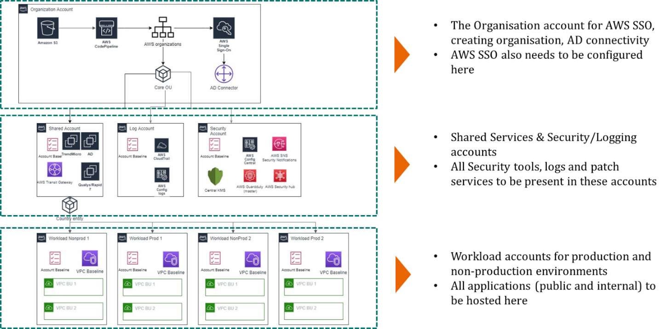

**Shared Services Account**

This AWS account is provisioned to host a set of shared services which are common across all other accounts such as-

* Bastion Hosts
* Active Directory Service
* Centrally Managed Shared Golden AMIs
* EBS and other Centralized backups
* Centralized DNS

The Shared Services account will host the Bastion hosts which will be used by OS administrators to logon to the instances of production and non-production workloads as OS level. The Shared Services account design will take the maximum amount of time and will be an integral part of the network design. The following components need to be decided while designing the Shared Services Account:

* Communication with other accounts
* Communication with on-premise or other clouds
* Transit gateway design and set-up
* Communication between VPCs

**Security Account**

It will aggregate the security and config events from all other AWS accounts using one or more of the following services:

* AWS Config
* AWS CloudTrail
* CloudWatch Alarms
* AWS GuardDuty

Thereafter, these alerts and notification will be forwarded to appropriate SNS topics subscribed for security and AWS config notification.

**Logging Account**

The logging account will centrally store CloudTrail and Config logs from all other accounts.

* This account will be completely isolated from all other AWS accounts.
* It will not host any service other than S3 buckets to store CloudTrail and Config logs sent from the other accounts.
* All the logs in the logging account will be encrypted using AWS KMS service.

**Workload Accounts**

The workload accounts are to be used to host the applications. Typically, the number of workload accounts have to be determined based on the objectives. The factors that influence the total number of workload accounts as well as the design of each account are as follows:

* Segregation with respect to environments, namely separate accounts for non-production and production workloads
* Segregation based on business units using the applications hosted in a workload account
* Segregation based on the type of applications hosted, such as internet and intranet workloads

**Network Design**

The Network design is based on the multi-account strategy described above. The design will be enhanced and granular level of details will be implemented after discussions with the Mahindra Finance architects. One important consideration for the network design will be to allow or disallow internet connectivity to the different AWS accounts. As a rule of thumb, only the Shared Services account will have internet gateway attached to it whereas the workload accounts will by default not have any internet access although provisions will be kept to enable that if required. Based on the internet availability of the accounts the workload accounts will be classified as follows:

**IAM Roles and Privileges**

User access management can be handled in AWS IAM but it is advisable to integrate IAM with the organization’s Active Directory. This will help the organization to centrally manage users’ authentication and authorizations. Alternatively, federation services such as ADFS can control user authentication from a centralized user management system. The decision on the option for centralizing user authentication needs to be discussed and finalized in the Design phase. The diagram below depicts the mechanism followed for user authentication via ADFS.

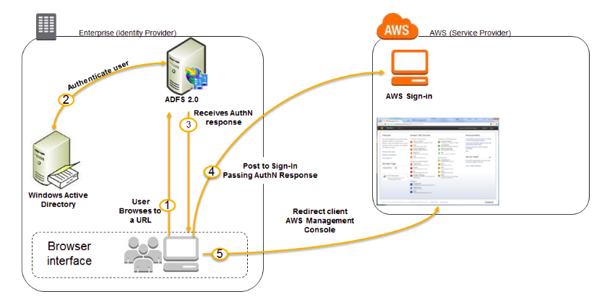

User Groups and Roles

The standard user roles and groups to be created are provided below. This may need addition of further roles and groups depending upon the country and number of roles to be created.

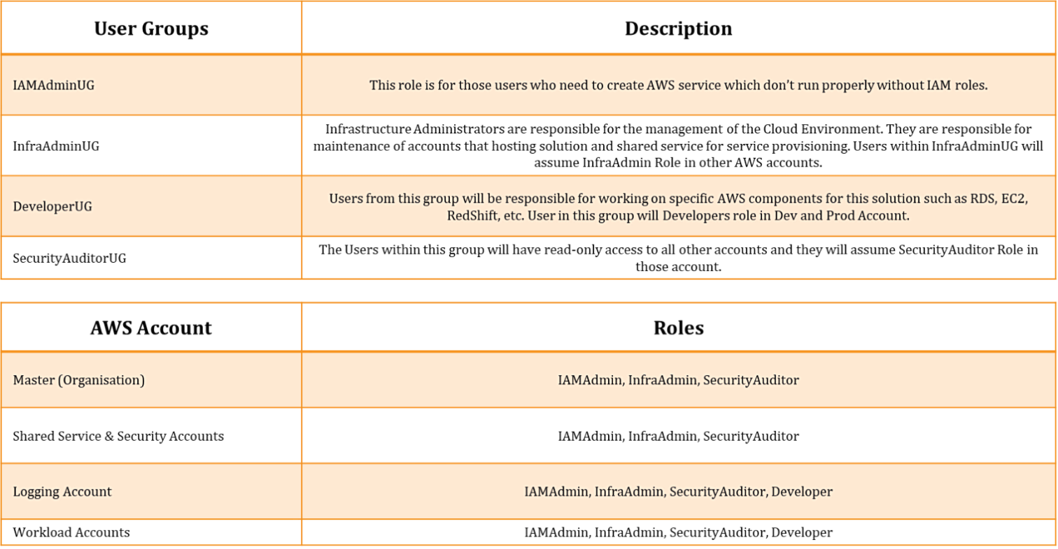

**Tagging Strategy**

A tag is a label that is assigned to an AWS resource. Each tag consists of a key and an optional value. Tags allow the categorization of AWS resources in different ways, such as, by purpose, owner, or environment. This is useful especially when there are multiple resources of the same type. Tags if assigned properly will help in quick identification of the resource. The strategy for tagging must be uniform across the organization. The following diagram depicts a standard tagging strategy.

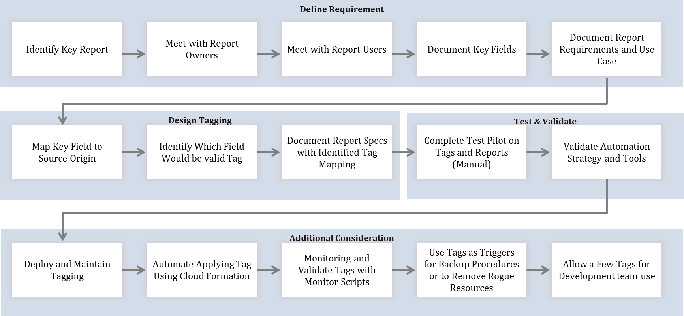

### AWS Account Setup

In this phase the readiness of the current application or AWS account setup are repurposed to AWS account and setting up of AWS infrastructure in line with existing setup. In this phase the required AWS resources are created and these resources are validated which will includes–

* Create necessary AWS Resources (If required)
  + Use customer inputs to run necessary automation scripts
  + Set-up security group templated using firewall rules from AWS setting
  + Configure AWS Guard Duty, AWS SNS and other configurational components
  + AWS environment ready network, security, monitoring, logging, and storage components

# Scope Of Work

## Pre-Requisites

Following are the pre-requisites to successfully deliver the activities in scope during this engagement.

* Executive commitment to the program to align internal support from IT, partners, and business
* Assign an Executive to work collaboratively with joint accountability of the program
* Provide AWS’s administrator/any other access to Blazeclan to start and work on the project
* Provide current AWS account access to Blazeclan’s resources
* Provide documentation of the current setup, configuration, network, security components of current AWS landing zone
* Share and provide regular updates on the other ongoing and planned programs that may impact the implementation plan and schedule of this project

## Activities In-Scope

Following are activities in-scope for this engagement

**Project Kick-Off**

* Project initiation and introduction to stakeholders
* Understand Mahindra Finance's business priorities, governance needs, AWS roadmap, constraints etc.
* Gain access to all existing documentation relevant to Customer's AWS environment and workloads

**Requirement Gathering**

* Detailed requirement gathering
  + Project Scope & Definition
  + Stakeholder Identification
  + Requirement gathering for Network and Infra
  + Requirement gathering from application team
  + Requirement gathering from security team
  + Gather requirements for identity & access management
* Assess existing security and compliance requirements
* Refine and analyse data captured during workshop

**Landing Zone Design and Setup**

* Create landing zone design document
* Review design document with stakeholders
* Update design document with feedback
* Assessment report based on finding
* Approval of landing zone design and sign-off from customer on the landing zone architecture

**AWS Account Setup**

* Setup multi-account structure with AWS Control Tower
* Integration for SSO Login
* Configure AWS shared services account
* Configure log archive account
* Configure security account
* Monitoring and logging strategy
* Implementing security baseline
* Configure IAM based on least privilege access
* Setup cloud native network and security configuration
* Configure AWS config rule and configure AWS SNS
* Configure AWS Guard Duty
* Configure AWS Key Management Service
* Cost allocation tags setup
* Assist customer to setup budget alert
* Backup and retention Strategy
* Test and Confirm setup
* AWS WAR

**Project Signoff and Handover**

* Handover project documentation
* Project Sign-Off

## Out Of Scope

* Any Assessment/Migration (Application/Data/Database etc.)
* Any changes required for on-premise components
* Implementation and configuration of any third-party firewalls, network devices and tools will not be performed by Blazeclan
* Antivirus setup
* VAPT scans
* VAPT finding resolution would be additional requirement
* Any network configuration outside of AWS will not be performed by Blazeclan
* Set-up of a separate Active Directory on AWS
* Creation of Operational guidelines for infrastructure management
* Migration of the applications & data in existing AWS accounts to the new Landing Zone
* Integration with SIEM tool
* Configuration of any third-party

# Indicative Plan

## Indicative Timelines

|  |  |
| --- | --- |
| Blazeclan |  |
| Joint |  |
| Mahindra Finance |  |

|  |  |  |  |  |  |  |  |  |
| --- | --- | --- | --- | --- | --- | --- | --- | --- |
| **Phases | Milestones | Activities** | **Wk1** | **Wk2** | **Wk3** | **Wk4** | **Wk5** | **Wk6** | **Wk7** | **Wk8** |
| Project Setup |  |  |  |  |  |  |  |  |
| Requirement Gathering |  |  |  |  |  |  |  |  |
| Landing Zone Design and strategy |  |  |  |  |  |  |  |  |
| AWS Control Tower setup |  |  |  |  |  |  |  |  |
| Implement network architecture |  |  |  |  |  |  |  |  |
| Validation of Landing zone |  |  |  |  |  |  |  |  |
| Handover and Signoff |  |  |  |  |  |  |  |  |

***\*Note:***

* Above timelines do not consider holidays and weekends, out of business hours.
* The above timelines are based on understanding from shared inventory, in case of any scope /inventory change found during the requirement gathering phase, timelines and efforts will be revisited.

# Risks, Assumptions & Dependencies

## Risks

|  |  |  |
| --- | --- | --- |
| # | **Risks** | **Mitigation** |
|  | Delays in commencement of the program to meet the desired timeline | * Proactive preparation of Proposal |
|  | Unavailability of relevant guidelines and documentation | * Gather all the relevant security and operational guidelines before the commencement of the engagement |
|  | Unavailability of Stakeholders during discovery and design phases may delay the requirement gathering, review, and low-level architecture | * Provide a detailed plan at the time of kick-off to get confirmation of the availability of relevant stakeholders during the assessment and the design phases |
|  | Delay in getting access to the AWS environment for Blazeclan | * Access must be arranged as a pre-requisite and to be provided just after the kick-off. * Blazeclan team will also provide the names of the individuals before the project kick-off |
|  | Delay in approvals and implementation of changed requests such as port openings, direct connect/VPN | * Communication must be done to the relevant infrastructure and network teams so that the expectation is known to the approvers and executors |

## Assumptions

* AWS infrastructure will be setup on Mahindra Finance AWS account
* Appropriate access to environment will be provided to Blazeclan team
* Migration or rearchitecting of application workloads will not be part of the scope
* Approvals on relevant items must be provided by Mahindra Finance within 2 working days. Any delay may impact overall timeline
* Mahindra Finance will be responsible for providing following support:
  + Be available for discussions as per scheduled meetings
  + Provide required AWS account access to Blazeclan team.
  + Ensure all the right stakeholders are available during the workshop
* Any 3rd party tool or license cost to be borne by Mahindra Finance
* All the software and tools that will be used for the activity will procured by Mahindra Finance
* AWS infrastructure cost will be borne by Mahindra Finance
* Training/handover session for migrated workload and operating model will be conducted on regular intervals, client is expected to align their team as per training schedule
* Security component finalization will be done during the requirement gathering phase

## Dependency

* Mahindra Finance will provide admin access on AWS accounts to Blazeclan engineers assigned to the project, any delay is required access will affect project schedule
* Mahindra Finance will appoint or identify a project owner to work with the Blazeclan Team and provide/arrange approvals from relevant stakeholders
* Mahindra Finance will provide all information and details of the architecture of their current environment to Blazeclan for creating network and security architecture on AWS
* Delay in any dependency will impact project schedule

# Commercials

## Professional Services Cost

Following is the services cost to implement the discussed solution for this engagement.

|  |  |  |  |
| --- | --- | --- | --- |
| **Payment Details** | | | |
| **Services** | **Pricing Model** | **Key Dates** | **Total Fee (INR)** |
| Implementation of AWS Landing zone using Control Tower | Fixed Price | TBD | **12,75,000** |
| **Total (excluding GST)** | | | **12,75,000** |

**\*\*Note**

* *All mentioned commercials are in* ***Indian Rupees (INR)***
* *All the quoted costs will be exclusive of any applicable taxes or transfer prices*
* *No licenses or AWS Services costs are considered and will directly be paid by the customer*
* *Any extension in timelines or additional workflows will result in CR*
* *This commercial does not include any travel or stay cost*

## Payment Milestone

|  |  |  |
| --- | --- | --- |
| **S No** | **Description** | **Payment Milestone** |
| 1 | Resource On-boarding | 40% of contract value |
| 2 | AWS Landing zone setup validation | 40% of contract value |
| 3 | Final Sign Off | 20% of contract value |

# Terms and Conditions

|  |  |
| --- | --- |
| **Terms & Conditions** | **Description** |
| Validity | The proposal is valid for 30 days from the date of the proposal submission. |
| Location of Service | The offshore consulting services will be performed at Blazeclan’s delivery center in Pune, India. |
| Travel | Any expense incurred as a result of unscheduled travel to Mahindra Finance offices within India or abroad will be charged to the customer at actual including accrued taxes. This will be subject to prior approval from customer. |
| Infrastructure | VoIP and landline-based communication will be used for communication between Blazeclan and Mahindra Finance. |
| Payment Terms | Blazeclan will issue invoices in electronic form to the customer as per the payment/invoice schedule. Blazeclan expects payment to be issued by the customer within **15 days** of the issue of the invoice, failing which Blazeclan will charge an interest of 1% per week. |
| Change of Scope | The scope of the project is as specified in this document. In the event of any change in the scope, Blazeclan will assess the impact of the change on the schedule and cost of the project. Blazeclan will present the revised schedule and cost to the customer. |

# Contract & Agreement

To confirm your offer to provide Services to Customers on the terms of this SOW, please sign below and send the entire SOW by email as a pdf file to [Bhavik.vyas@blazeclan.com](mailto:Bhavik.vyas@blazeclan.com).

**Term**

The Term or Period of Performance during which the Scope of Services will be performed as set out in the Purchase Summary above unless otherwise mutually agreed by the parties in writing.

Each party has executed this Order Form by its duly authorized representative.

|  |  |  |
| --- | --- | --- |
| **Blazeclan Technologies India Ltd.** |  | **Mahindra Financial Services Limited** |
| Signature |  | Signature |
| Printed Name |  | Printed Name |
| Title |  | Title |
| Date |  | Date |

# Appendix

## About Blazeclan

Blazeclan Technologies established in 2010 in Pune, India, is one of the world’s leading niche providers of digital and cloud services, with a presence in over 4 continents and a global workforce of over **750+** people. Blazeclan’s Vision is to become the world’s **leading Digital and Cloud services** company that delivers business value to our customers with the highest level of customer satisfaction. Its talent pool constitutes more than **350+ AWS certifications and 60+ Azure certifications,** and it is one of the top **AWS Premier Consulting Partners** in the world with over **200 global clients**. Our focus and investments in AWS have catalyzed our success and resulted in us achieving the following competency with AWS.



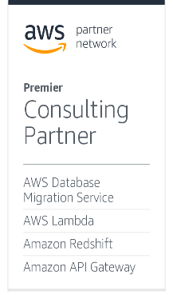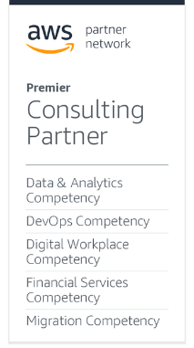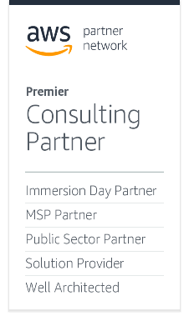

Blazeclan provides its clients with insights and capabilities that boost their freedom enabling them to achieve superior results through a unique work method - **Shared Business Excellence**. By cooperating with clients as an extended team, Blazeclan creates and delivers Digital and Cloud solutions that fit their needs and drive results. As a deep niche, innovative and people-focused organization, Blazeclan has developed its unique approach to achieving value for its clients through a distributed delivery model with an appropriate mix of offshore and onshore for each service in the comprehensive catalogue. We have **6 offices around the world** with our global **delivery centre in Pune, India**. Blazeclan has a broad customer base in industry sectors of Financial Services, Media and Entertainment, and Emerging markets and has invested in developing the capabilities and solutions aligned to industries to deliver cloud-enabled transformations.

Blazeclan has been consistently recognized for excellence and provides end-to-end Digital and Cloud Services to customers with **AGILITY, AUTOMATION & ASSURANCE.** Few of the recent recognitions include:

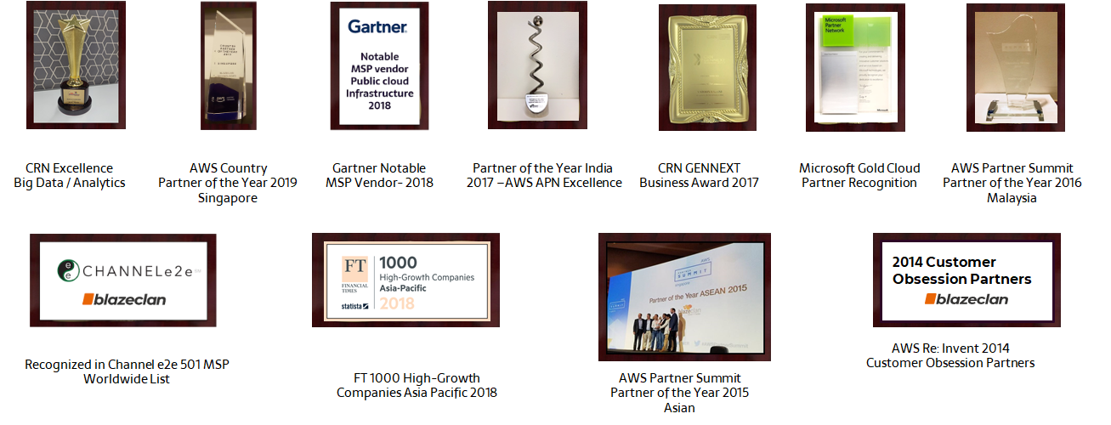

Included below are customers where we have engaged and successfully delivered the expected outcomes across domains.



**Global Footprints**

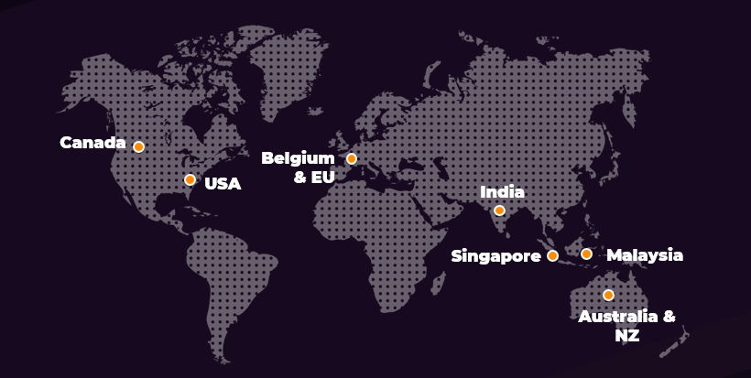

Blazeclan provides the following services to the market and our customers. Most of these services are relevant and align to the service grouping of clients and will enable the client to have a trusted partner, that can provide thought leadership and operational excellence.



|  |  |
| --- | --- |
| **Consulting & Advisory Services** | We will help you build your digital and cloud strategy. Our focus will be on understanding your priorities, defining a comprehensive digital and cloud adoption blueprint and conclusively assessing the potential for cloud-enabled transformation. Our assessment methodology is data-driven and provides an end-state architecture, business case and deployment roadmap. |
| **Cloud Migration Services** | Whether you have a customer-facing application – web-based or mobile, enterprise applications like SAP, Oracle E-Business Suite, Microsoft, ERP, CRM, Portal, or legacy environments, we have the experience and expertise to chart out an effective plan of migration to the cloud with near-zero downtime thus ensuring business continuity. |
| **Managed Services** | Blazeclan’s transition methodology and 24/7 Managed Services allow you to focus on your business while our highly qualified team of Applications, SysOps & DevOps Engineers take care of the high availability, scalability and security of your Infrastructure and Applications. Our automated Cloud Management Platform (CMP) delivers automation to optimize your costs. |
| **DevOps & Automation Services** | With our unique discovery-based methodology for the implementation of complex DevOps projects, we help create strategic roadmaps for successful DevOps project executions. We have frameworks and tools, and partnerships with leading product vendors to enable simple setup, operation and continuous innovation. |
| **Data, Analytics and Insights Services** | Data is the foundation of innovation, and it is here to stay. Blazeclan’s Data, Analytics and Insights offerings and solutions are designed to help organizations accelerate the setup of a secure data-driven decisioning platform by using the power of the cloud and proven frameworks and tools. The Offering enables the cognitive NLP, ML and AI aspects for the business. |
| **Digital Services** | Through our Digital Services blended with the Agile Development Methodology, and our approach & expertise in product development, we could help you accelerate your time to value by designing, architecting to cloud-native using microservices/serverless, deploying adaptive technology solutions and delivering required CX/UX for the customers. |